Foot Zone Therapy

**Christine Christensen: Certified Foot Zone Therapist / Instructor**



***Foot Zone Therapy is an amazing new healing modality that creates synergy and enhances all bodily functions.***

***Relax & rejuvenate your body & mind.***

**Foot Zone Therapy is precise, directed pressure to the various “zones” of the feet (similar to deep tissue massage). When a signal point is triggered within a certain zone, a message goes to the tissue or organ affected, through a reflex arc to the spinal cord and then to the brain. Discomfort is experienced in the areas of imbalance–areas where healing is needed.**

**Zone Therapy encourages the body’s natural healing capability**

**by stimulating:**

* **blood circulation**
* **hormone balance**
* **elimination**
* **function of the autonomic nervous system**

**Most important benefits include:**

* **renewing cell systems**
* **rejuvenating life energy**

**Anyone will benefit from Zone Therapy. People of all ages and all   
conditions of health can enjoy improved health and vitality. You will   
experience a fuller more active life and can help others do the same.**

***Schedule an appointment for a total body tune up.***

**425-293-6136**

**1705 174th PL SE, Bothell, WA 98012**

**For information on certification classes see:**

**academyoffootzonetherapy.com**

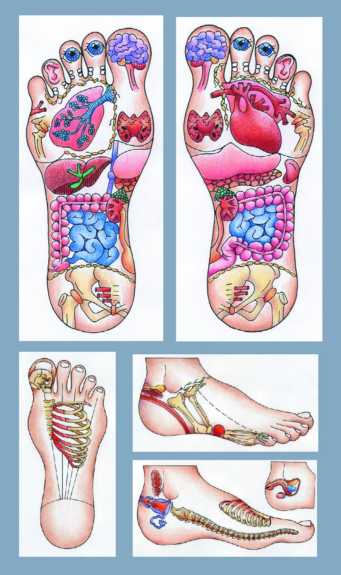

* **lymph flow**
* **digestion**
* **assimilation**
* **bringing the body into balance**
* **assess body’s current state of health**

Coupon valid for **$10 off**

first Foot Zone Therapy Treatment (reg $60)

Information About & Benefits of: Foot Zone Therapy

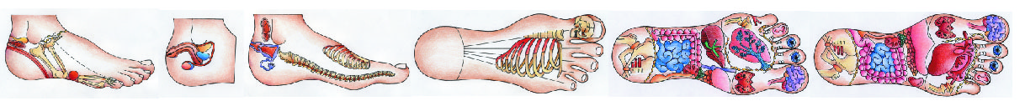Different from reflexology, Foot Zone Therapy treats the body as a whole, re-establishing the communication and synergy between all organs and cells. Foot Zone Therapy has been found to be a “signal”, or electro-magnetic system rather than a reflex system, and treats the body holistically rather than symptomatically. Each treatment energizes the entire system and every cell. This process involves triggering a corrective signal to an area that is inhibiting the body from working at optimal levels. It is a precise physical therapy applied via directed pressure to the various “zones” of the feet, stimulating the nerves and encouraging circulation to specific areas of the body. The Foot Zone Therapy practitioner observes the foot and interprets the “messages” it conveys through discoloration, spots, disruptions and pain. When a signal point is triggered within a certain zone, a message goes to the tissue or organ effected, through a reflex arc to the spinal cord and then to the brain. Discomfort is experienced in the areas of imbalance-areas where healing is needed. A complex signal system located in the feet connects to every organ, system and cell in the body. Foot Zone Therapy always stimulates every organ and renews the cell system in each treatment. Zone Therapy is a holistic approach which recognizes that all of the body’s cells and organs make up one, complex, interactive organism. Acute and chronic conditions are benefited by the help and support of Zone Therapy, by strengthening all surrounding zones which can in turn help support an ailing zone. This encourages the entire body to heal itself. Zone Balance does take time. It works with the body’s own innate intelligence, and only allows the body to do what it can when it can.

History of Zone Therapy

Zone Therapy, in some form has been practiced as a healing method for thousands of years. It has come and gone with the rise and fall of civilizations. Hieroglyphics and ancient paintings depicting this therapy have been found in Egypt and India. The modern history of Zone Therapy begins with Dr. William Fitzgerald, (1872-1946) an American nose and throat specialist. He developed a theory describing the electrical circuits or meridians in the body, and in the 1950’s a Norwegian named Dr. Charles Ersdal, M.D., M.A., used Zone Therapy to cure himself of paralysis. After 23 years of intensive clinical research, Ersdal was able to chart the human anatomy as it relates to these “points” on the foot. He charted the entire physiology including the brain, blood and lymph circulation, and musculature and has codified his findings into a medical science widely respected throughout Europe.

Imbalances or the early stages of ill health occur long before the symptoms are manifested. By the time detection occurs the problem is usually well advanced. With Zone Therapy you gain early detection and treatment of these imbalances as they occur. Zone Therapy encourages the body’s natural healing capability.

What to expect from your Foot Zone Therapy Treatment:

Because the whole body is run by instruction from the brain, Foot Zone Therapy is extremely effective as it works with the nervous system via the brain. As the therapist triggers points on the foot, the brain makes the corrections to your whole health system. Much more occurs during a session than meets your eye or awareness, and practitioner experience is essential to achieving the full physical, mental and emotional benefit. Multiple and consistent sessions over a two - four month period are recommended to detoxify and establish the bodies restorative process. After this period, you and your therapist will determine a schedule based on your individual needs and condition. You will find that your body will tell you when it’s time for a Zone!

Some people feel energized after a Foot Zone, some experience relaxation and relief from stress, deeper sleep, more active digestive system or emotional release that results in crying. Depending on your health and sensitivity, you may feel tired or experience flu-like symptoms, because the body responds by needing rest to repair itself.

It is recommended to drink plenty of water before and after a treatment to flush your system and to enhance the electrical flow of the nervous system.

The goal of a Foot Zone treatment/balance is to open up signals in the feet. If the signals are shut down, you may experience discomfort. Everyone has a different experience ranging from no discomfort to intense discomfort, which usually diminishes with consistent treatments. The initial treatments typically last one hour, subsequent treatments are 45 – 55 minutes.

